Operations of the Magnetospheric Multiscale Mission (MMS) and University of New Hampshire’s Contributions

ABSTRACT

1. **Introduction and Background**

“MMS was uniquely designed to answer a central question in what we call Space Plasma Physics…” - Roy Torbert, Professor of Physics & UNH Space Science Center

The question the Magnetospheric Multiscale Mission (MMS) was designed to answer was “Is what is the process that seems to be able to release rapidly, the energy stored a magnetic field…” Professor Torbert when on to say. (Potier, 8.) MMS is a NASA space mission to study the Earth’s magnetosphere and its properties. MMS will specifically gather information on energetic particle acceleration, magnetic reconnection and other areas of astrophysical plasmas.

The MMS mission builds upon the discoveries and advances of the ESA Cluster II mission. A similar mission where the European Space Agency and NASA partnered to study the Earths magnetosphere over the course of nearly two solar cycles. (“Cluster II (Spacecraft), 3.) The ESA Cluster II mission was a replacement mission for the original Cluster spacecrafts that were lost in a launch failure in 1966 aboard an Ariane 5 G rocket. (“Cluster (Spacecraft), 2.)

MMS mission will consist of three operational phases, the commissioning phase and two scientific phases. During the commissioning phase, the spacecraft will orient themselves and preform preliminary testing prior to operations. The first scientific phase will investigate the magnetic boundary between the Earth and the Sun (day side operations). The second scientific phase will study the reconnection activity in the Earth’s magnetic tail (night side operations). (“Magnetospheric Multiscale Mission.”, 6.) This phase lasted five and a half months after launch, with the scientific phases lasting a total of two years to make the planned mission duration of 2 years, 5.5 months.

1. **Purpose and Magnetic Reconnection theory**

The instrumentation and measurements made by MMS will exceed that of the ESA Cluster II mission in terms of spatial and temporal resolution. This resolution has allowed us to take and analyze data from the critical electron diffusion region, the location of magnetic reconnection. “Magnetic reconnection is a universal phenomenon where energy is efficiently converted from the magnetic field to charged particles as a result of global magnetic topology changes during which earlier separated plasma regions become magnetically connected.” (Andris, 1.)

As with most concepts in physics, you start with the fundamentals, proceed with models, and then develop a thorough analysis. Thus, the best place to start with magnetic reconnection is the Maxwellian equations.

$$∇×B=μ_{0}J+\frac{1}{c^{2}}\frac{∂E}{∂t} (1)$$

$$∇×E=-\frac{∂B}{∂t} (2)$$

$$∇⋅E=\frac{ρ}{ε_{0}} (3)$$

$$∇⋅B=0 (4)$$

The Maxwellian equations form the foundations of electric circuits, classical optics, and electromagnetism. The are a set of partial differential equations that incorporate the Lorentz force law. Critically, they demonstrate how time varying magnetic and electric fields propagate within a vacuum at a constant speed (c). (“Maxwell’s Equations.”, 7.) From theses fundamentals, two theoretical frameworks of magnetic reconnection have been created. The Sweet-Parker model by Peter Sweet and Eugene Parker in 1956 and the Petschek model by Harry Petschek in 1964. (“Magnetic Reconnection.”, 5.)

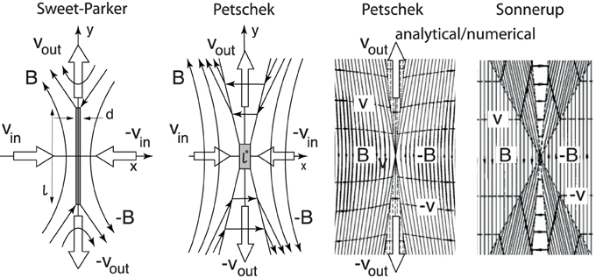

Figure 1 Sweet-Parker and Petschek. Two basic fluid models of reconnection.

Sweet-Parker model

The Sweet Parker model centers around time-independent magnetic reconnection in a resistive magnetohydrodynamic frame when the reconnecting magnetic fields are in opposed direction. This model has its advantages and disadvantages. The Sweet-Parker model interprets reconnection rates faster than that of global diffusion but is incapable of explaining the fast reconnection rates found in the Earths magnetosphere and solar flares. (“Magnetic Reconnection.”, 5.)

$$\frac{∂B}{∂t}=\left(∇×\left(u×B\right)\right)+η∇^{2}B (5)$$

Equation (5) demonstrates the magnetic diffusivity equations, this describes how non-uniformities in a magnetic field will be flattened out.

Petschek model

The Petschek model was required for further explanation of magnetic reconnection because of its limitation in reconnective speed. The Petschek model proposed a mechanism where the outflow and inflow regions are separated by static sow mode shocks. With these properties the aspect ration of the diffusion region allows the maximum reconnective rate to be described with the equation below.

$$\frac{v_{in}}{v_{A}}≈\frac{π}{8\ln{S}} (6)$$

Equation (6) allows for faster and more realistic reconnective rates than the Sweet-Parker model and is nearly independent of the Lundquist number. (“Magnetic Reconnection”, 5.)

1. **Instrumentations and Operations**

The primary instruments abord the Magneto Multiscale Mission were divided into three different groups, each corresponding with a specific investigation. Apart from scientific instruments, each satellite within the MMS required its own controls systems. (Garner, 4.)

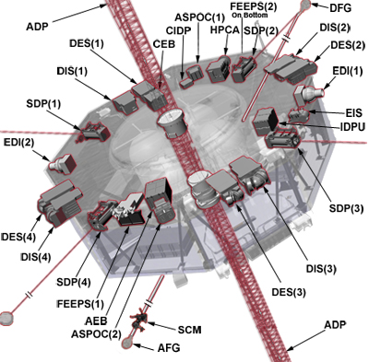

Figure 2 Singular MMS Satellite Scientific Instruments

Hot Plasma Suite: Observations on the nature of plasma, or charged gas, during reconnection.

Instrumentation:

* Fast Plasma Investigation
  + Dual Ion Sensors (DIS)
  + Dual Electron Sensors (DES)
  + Data Processing Unit (IDPU)
* Hot Plasma Composition Analyzer (HPCA)

Energetic Particle Detector Suite: Observations of fast moving, energetic particles.

Instrumentation:

* Fly's Eye Energetic Particle Sensor (FEEPS)
* Energetic Ion Spectrometer (EIS)

Field Suite: Observations on electric and magnetic fields and waves.

Instrumentation:

* Analog Fluxgate Magnetometer (AFG)
* Digital Fluxgate Magnetometer (DFG)
* Electron Drift Instrument (EDI)
* Spin-plane Double Probe (SDP)
* Axial Double Probe (ADP)
* Axial Electronic Box (AEB)
* Search Coil Magnetometer (SCM)
* Central Electronics (CEB)

Instrument Controls:

Instrumentation:

* Active Spacecraft Potential Control Device (ASPOC)
* Central Instrument Data Processor (CIDP)

**“**At UNH, a team of nearly 40 people — scientists, engineers, managers, software developers, machinists, technicians and students — delivered a suite of six sensors per spacecraft called the FIELDS instrument suite.” (Potier, 8). At the center of magnetic reconnection lies the fact that magnetic fields are dynamic environments, the FIELDS Suite has the job of observing these fields. At the orbital speed of MMS, it will travel through reconnection regions in under a sec. Thus, the FIELDS suite can record data at speeds greater than I kHz. For simplicity, I will only go into the instrumentation that the University of New Hampshire’s Space Science Center was responsible for and contributed to within the FIELDS Suite.

Electron Drift Instrument (EDI): EDI measures both the magnetic and electric fields by following the path of an electron beam through space. Then, the EDI sends a beam of electrons out into space with both of its Gun Detector Units. When in the presence of a magnetic field, the electron beam will curve around on itself until it reaches the second Gun Detector Unit. Finally, by taking the time of the path, we can calculate the strength of the magnetic field.

The Spin-plane Double Probe (SDP) and the Axial Double Probe (ADP): Each instrument calculated the electric field present by measuring the voltage between two electrodes. These instruments are deployed upon booms set far away from the body of the spacecraft. The purpose of this extension is to provide as significant a change in signal as possible, as electric field variations are often quite small.

FIELDS Central Electronics (CEB): Once each of the FIELDS Suite instrument measurements are made and collected, it is the responsibility of the CEB to transmit this data. This information is often cross-calibrated, providing extremely precise measurements.

1. **Discoveries and Contributions**

On March 13th, 2015, the Magnetospheric Multiscale Mission launched aboard Atlas V 421 at 02:44 UTC. Since that date it has been 5 years, 1 month, and 19 days, far surpassing the 2 years, 5.5 month planned mission duration. As of March 2020, the mission will have enough fuel upon the spacecrafts to remain active until 2040.

While MMS is flying through regions of high interest within its orbit, the spacecraft maintain a tetrahedral formation to collect the desired measurements with accuracy. A high-altitude GPS receiver called Navigator, is used to maintain and prove orbital knowledge during MMS’s flight. In 2016 and 2019, MMS has broken the Guinness World Record for highest altitude fix through GPS at 43,500 and 115,300 miles, respectively. (“Magnetospheric Multiscale Mission”, 6.)



Figure 3 Magnetic Reconnection

During its first scientific phase, in 2016, the MMS first directly detected magnetic reconnection. “This dataset is so revolutionary that I think we’ll be mining it for 50 years…We were confident that we would be able to get some important data from the mission but to do it as quickly and accurately as we did was just amazing.” Quote Professor Roy Torbert. (Potier, 8.)

Since that initial interaction, MMS has encountered magnetic reconnection in unexpected places. In 2018 the spacecraft made the first ever recording of magnetic reconnection in the magnetosheath. This discovery was unexpected due to the chaotic and unstable nature of the magnetosheath, once thought to be volatile for reconnection. This discovery was not the only one of its kind, again unexpected, MMS encountered Magnetic flux ropes, and Kelvin-Helmholtz vortices. Most recently, scientists have claimed that MMS has recorded high resolution measurements of interplanetary shock waves, originating from the sun. (“Magnetospheric Multiscale Mission”, 6.)

1. **Conclusion**

The Magnetospheric Multiscale Mission proved itself in many aspects, even long before its launch. With the contact and contribution, it allowed UNH to prove its ability to provide NASA with the most up to date instrumentation for its spacecraft. MMS also championed collaboration with Universities and public institutions by completing a planned mission successfully and exceeding expectations. The MMS spacecraft themselves are still vital to space plasma physics to this day. Discoveries will continue to be made with new information, and continued analysis of old data will unveil what lies below the surface.

Work Cited

1. Andris, et al. “Microphysics of Magnetic Reconnection.” *NASA/ADS*, ui.adsabs.harvard.edu/abs/2006SSRv..122...19V/abstract.
2. “Cluster (Spacecraft).” *Wikipedia*, Wikimedia Foundation, 22 Apr. 2020, en.wikipedia.org/wiki/Cluster_(spacecraft).
3. “Cluster II (Spacecraft).” *Wikipedia*, Wikimedia Foundation, 20 Apr. 2020, en.wikipedia.org/wiki/Cluster_II_(spacecraft).
4. Garner, Rob. “Instruments Aboard MMS.” *NASA*, NASA, 2 Apr. 2015, www.nasa.gov/mission_pages/mms/spacecraft/mms-instruments.html#ceb.
5. “Magnetic Reconnection.” *Wikipedia*, Wikimedia Foundation, 2 Apr. 2020, en.wikipedia.org/wiki/Magnetic_reconnection.
6. “Magnetospheric Multiscale Mission.” *Wikipedia*, Wikimedia Foundation, 17 Apr. 2020, en.wikipedia.org/wiki/Magnetospheric_Multiscale_Mission.
7. “Maxwell's Equations.” *Wikipedia*, Wikimedia Foundation, 27 Apr. 2020, en.wikipedia.org/wiki/Maxwell's_equations.
8. Potier, Beth. “Magnetic Reconnection.” *UNH Today*, 12 May 2016, www.unh.edu/unhtoday/2016/05/magnetic-reconnection.